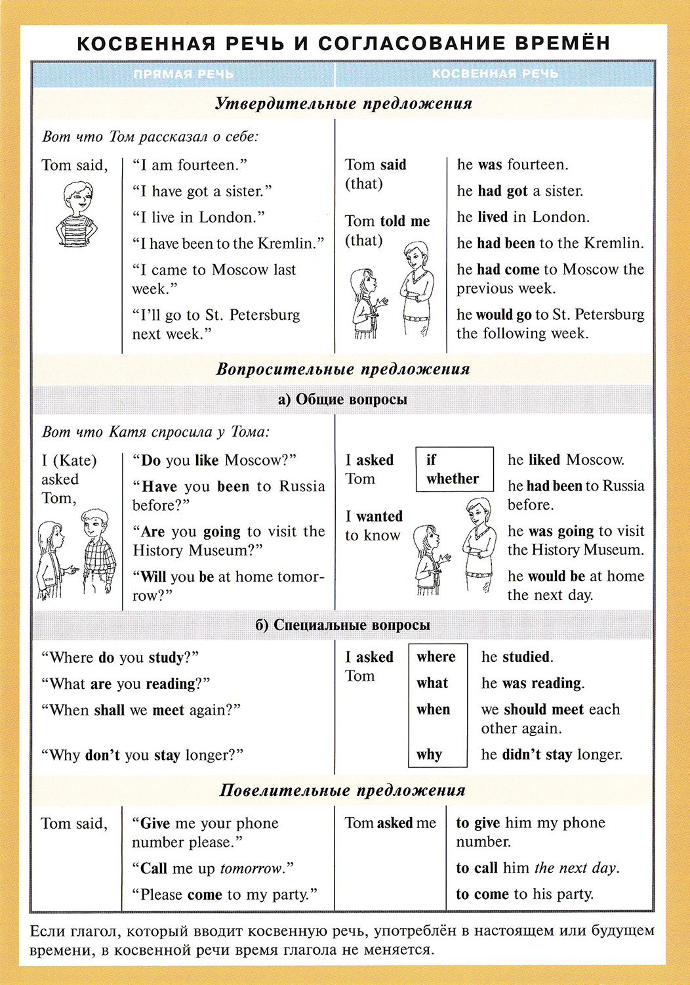
Прямая речь: | Косвенная речь:
tonight, today, this week / month / year  here | that night, that day, that week / month / year  there
now | then, at that time, at once, immediately
now that | since
1 yesterday, last night / week / month / year | the day before, the previous night / week / month / year
I tomorrow, next week / month / year | the day after, the next / following day, the next / following week / month / year
two days / months / years, etc., ago | two days / months / years, etc., before
"He arrived last week," she said. | She said (that) he had arrived the previous week.

